Embedding Superset Dashboard in your website

Overview
This document explains how to securely embed a Superset dashboard into a website using the Guest Token, generated dynamically via username/password authentication and CSRF token, combined with Row-Level Security (RLS).

Pre-Requisites
- Superset Setup:
- A Superset instance with dashboards and datasets configured.
- RLS policies applied to the datasets as required.
- Authentication Details:
- A valid Superset username and password for an account with access to the dashboard.
- API Access:
- The Superset API endpoint must be accessible.
- Web Development Knowledge:
- Familiarity with HTML, JavaScript, and API integration.

Steps to Embed the Dashboard

Step 1: Authenticate and Get access Token
Use the Superset API to log in with the username and password, and retrieve the access token.
Login Endpoint:
Make a POST request to /api/v1/security/login with your Superset credentials.
Example Request:

async function getAccessToken(username, password) {
const loginUrl = 'https://superset.example.com/api/v1/security/login';

const response = await fetch(loginUrl, {
method: 'POST',
headers: {
'Content-Type': 'application/json',
},
body: JSON.stringify({
username: username,
password: password,
provider: 'db', // Adjust based on your authentication method
refresh: true
}),
});

if (!response.ok) {
throw new Error('Login failed');
}

const data = await response.json();
return data.access_token; // Extract the access token
}



Step 2: Get CSRF Token.
CSRF Endpoint:
Make a GET request to /api/v1/security/csrf_token with the access token.
Example Request:

async function getCSRFToken(username, password) {
const csrfTokenUrl = 'https://superset.example.com/api/v1/security/csrf_token';

const response = await fetch(csrfTokenUrl, {
method: 'GET',
headers: {
'Content-Type': 'application/json',
'Authorization': 'Bearer {{access_token}}'
},
});

if (!response.ok) {
throw new Error('Token fetch failed');
}

const data = await response.json();
return data.result; // Extract the CSRF token
}



Step 3: Get Guest Token.
Once you have the access token and CSRF token, use it to make an API request to the guest token endpoint.
- Guest Token Endpoint:
- Make a POST request to /api/v1/security/guest_token/ with the CSRF token and payload.
Payload:
- Include the username, dashboard resources, and RLS rules.

Example Request:

async function generateGuestToken(csrfToken, username, dashboardId, rlsClause) {
const guestTokenUrl = 'https://superset.example.com/api/v1/security/guest_token/';

const payload = {
user: { username: username }, // username for the superset user
resources: [
{
type: 'dashboard',
id: dashboardId,
},
],
rls: [
{
dataset: 'DATASET_NAME', // Replace with the dataset name
clause: rlsClause, // RLS clause like "user_id = '12345'"
},
],
};

const response = await fetch(guestTokenUrl, {
method: 'POST',
headers: {
'Content-Type': 'application/json',
'X-CSRFToken': csrfToken, // Include the CSRF token in the header
'Authorization': 'Bearer {{access_token}}'

},
body: JSON.stringify(payload),
});

if (!response.ok) {
throw new Error('Guest token generation failed');
}

const data = await response.json();
return data.token; // Extract the guest token
}



Step 4: Embed dashboard

Once you get the guest token you can use it with superset embedded sdk library to view your dashboards in the web application

Things required in the sdk

- Id (click on embed dashboard -> copy dashboard id )
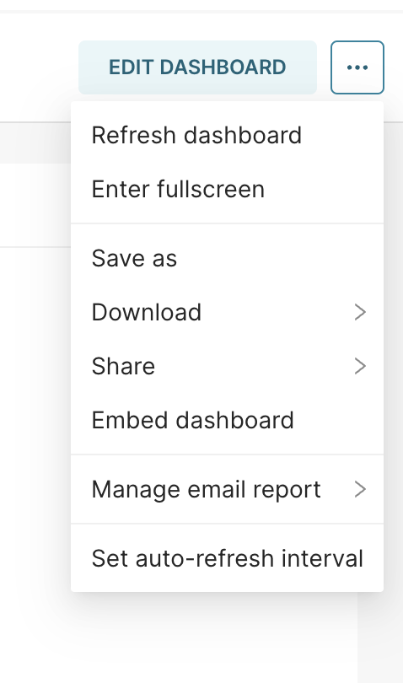
- fetchGuestToken function (this function needs to be created using the above mentioned APIs)

